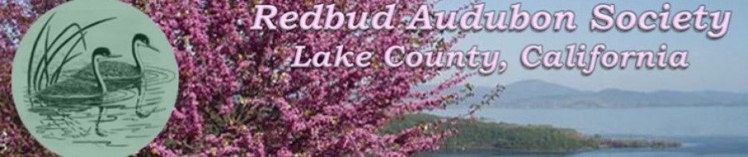

Comment on Proposed Reduction of Riparian Setbacks for Cannabis Cultivation
To: Lake County Community Development Department, Planning Division
Subject: Opposition to proposed reduction of riparian setback from 100 feet to 50 feet for cannabis cultivation projects
Date: October 8,2025 From: Redbud Audubon Society

1. Concern Regarding Setback Reduction
Reducing the riparian setback for cannabis cultivation from 100 feet to 50 feet is a serious environmental and regulatory concern. This change would undermine protections for aquatic and riparian ecosystems that support Clear Lake hitch (Lavinia exilicauda chi), a federally listed Threatened species (U.S. Fish and Wildlife Service, Final Rule, 2025). Hitch depend upon the tributary creeks of Clear Lake for spawning and early rearing, and these habitats are already highly degraded and fragmented.

2. Relevant Regulatory Standards
The State Water Resources Control Board’s Cannabis Cultivation Policy—Principles and Guidelines for Cannabis Cultivation (2019) establishes statewide minimum riparian setbacks measured from the bankfull stage:
- 150 feet for Class I waters (perennial, fish-bearing streams, lakes, or springs);
- 100 feet for Class II waters (intermittent streams or wetlands); and
- 50 feet for Class III ephemeral drainages.
Pumps, tanks, waste storage, and chemical handling are prohibited within these setbacks, and any diversion must include a CDFW-approved fish screen to prevent entrainment (Cannabis Policy §2.3.3; Appendix A, Table 1).
If Lake County were to align to only the minimum 50-foot buffer, it would effectively treat all watercourses as non-fish-bearing Class III streams—an inaccurate assumption for the Schindler Creek watershed and similar tributaries known to support Clear Lake hitch spawning runs. CEQA requires that local policies not weaken environmental baselines when site-specific biological data are absent.

3. Biological and Hydrological Implications
According to the U.S. Fish and Wildlife Service (Species Status Assessment, 2024) and CDFW observations, Clear Lake hitch migrate multiple miles upstream from Clear Lake into tributary creeks between February and May for spawning, with verified distances of:
- ~3 miles up Kelsey Creek
- ~5 miles up Adobe Creek
- ~2.5 miles up Middle Creek
- ~1 mile up Cole Creek
Barriers and sedimentation have already eliminated access to roughly 30 miles of historic spawning habitat. Any further reduction of riparian buffers risks:
- Thermal loading and loss of canopy shade, elevating water temperatures beyond tolerable levels;
- Sedimentation and nutrient runoff from disturbed soils entering spawning gravels; and
- Loss of seasonal wetland function, particularly where no formal wetland delineations have been conducted under CEQA Guidelines §15065(a)(1) and §15125(a).

4. CEQA Compliance and Recommendation
Reducing the setback in the absence of site-specific biological assessments or professional wetland delineations violates CEQA’s requirement for a complete and accurate environmental baseline (CEQA Guidelines §15125) and its mandate to avoid or mitigate impacts to federally protected species (§15065(a)(1)).
The County should retain or increase the current 100-foot setback and require:
- A qualified professional wetland delineation verified by CDFW or the Regional Water Board;
- Site-specific classification of watercourses (Class I, II, III) before approving reduced setbacks; and
- Demonstration that no impact will occur to Clear Lake hitch or its spawning habitat, supported by agency consultation under Fish and Game Code §§1600–1616 and Public Resources Code §21080.3.1 (AB 52).

5. Summary
In summary, aligning Lake County’s standard to a universal 50-foot setback would reduce environmental safeguards, disregard site-specific biological data, and conflict with both state and federal conservation mandates protecting Clear Lake hitch. We urge the County to maintain the current 100-foot buffer minimum—or preferably adopt the State Water Board’s 150-foot standard for Class I watercourses—until hydrologic and biological studies verify otherwise.

Respectfully submitted,
Donna Mackiewicz on behalf on the Redbud Audubon Society
PO Box 5780, Clearlake, CA 95422

